Ex 9

1)

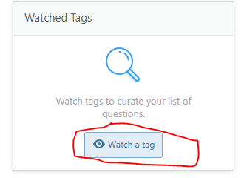Watch a tag

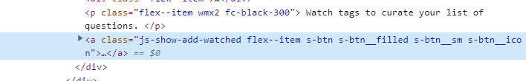

**DOM Locator**

document.getElementById("content").children[1].children[2].children[0].children[1].children[2].children[2]

**CSS Locator**

#sidebar > div.js-tag-preferences-container > div:nth-child(1) > div.s-sidebarwidget--content.fd-column > div.js-show-add-watched-container.d-flex.fd-column.ta-center.ai-center.gsy.gs16.mx-auto > a

**xPath Locator**

//*[@id="sidebar"]/div[3]/div[1]/div[2]/div[3]/a

2)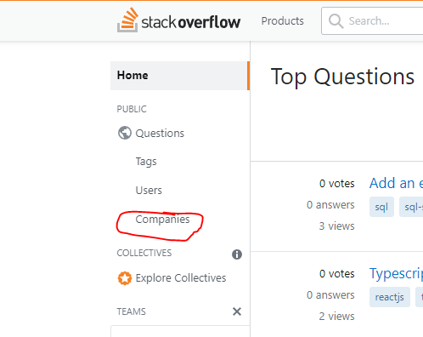companies

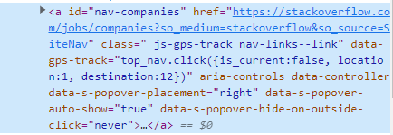

**DOM Locator**

document.getElementById("left-sidebar").children[0].children[0].children[0].children[1].children[0].children[4].children[0]

**CSS Locator**

#nav-companies

**xPath Locator**

//*[@id="nav-companies"]

**3)** 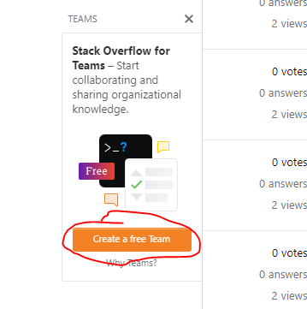 Create a free Team

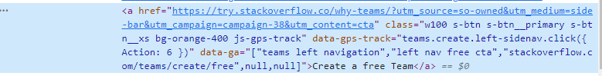

**DOM Locator**

document.getElementById("left-sidebar").children[0].children[0].children[0].children[2].children[0].children[0].children[2].children[2]

**CSS Locator**

#left-sidebar > div.left-sidebar--sticky-container.js-sticky-leftnav > nav > ol > li:nth-child(3) > ol > div > div.bt.bl.bb.bc-black-075.p12.pb6.fc-black-600.blr-sm.overflow-hidden > a.w100.s-btn.s-btn__primary.s-btn__xs.bg-orange-400.js-gps-track

**xPath Locator**

//*[@id="left-sidebar"]/div[1]/nav/ol/li[3]/ol/div/div[2]/a[1]

**4)** 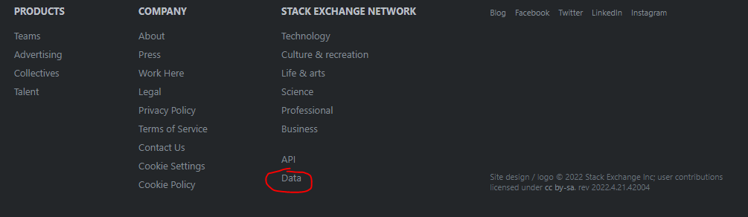Footer Data



**DOM Locator**

document.getElementById("footer").children[0].children[1].children[3].children[0].children[1].children[7].children[0]

**CSS Locator**

#footer > div > nav > div.site-footer--col.site-footer--categories-nav > div > ul > li:nth-child(8) > a

**xPath Locator**

//*[@id="footer"]/div/nav/div[4]/div/ul/li[8]/a

**5)** 

Search

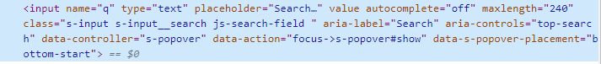

**DOM Locator**

document.getElementById("search").children[0].children[0]

**CSS Locator**

#search > div > input

**xPath Locator**

//*[@id="search"]/div/input